|  |  |
| --- | --- |
| **Date** | **05 November 2022** |
| **Team ID** | **PNT2022TMID25975** |
| **Project Name** | **Gas Leakage monitoring & Alerting system for Industries** |
| **Maximum Marks** | **20 marks** |

* create the IBM Cloud services which are being used in this project

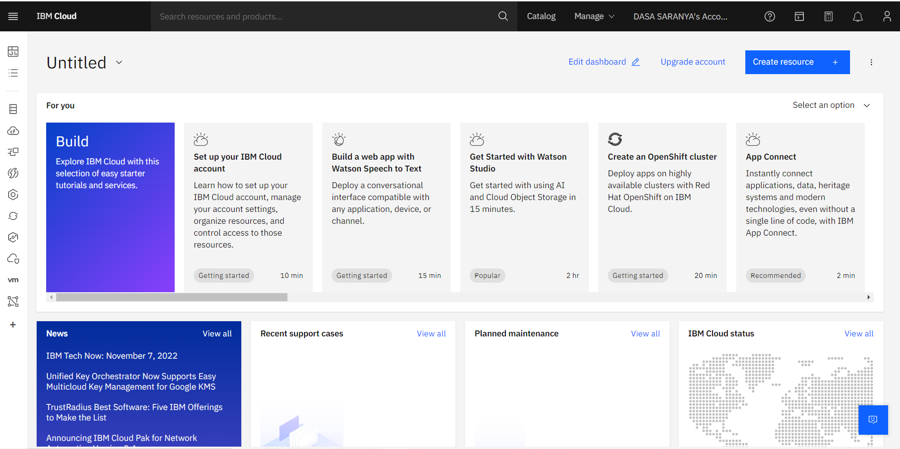

* Configure the IBM Cloud services which are being used in completing this project.

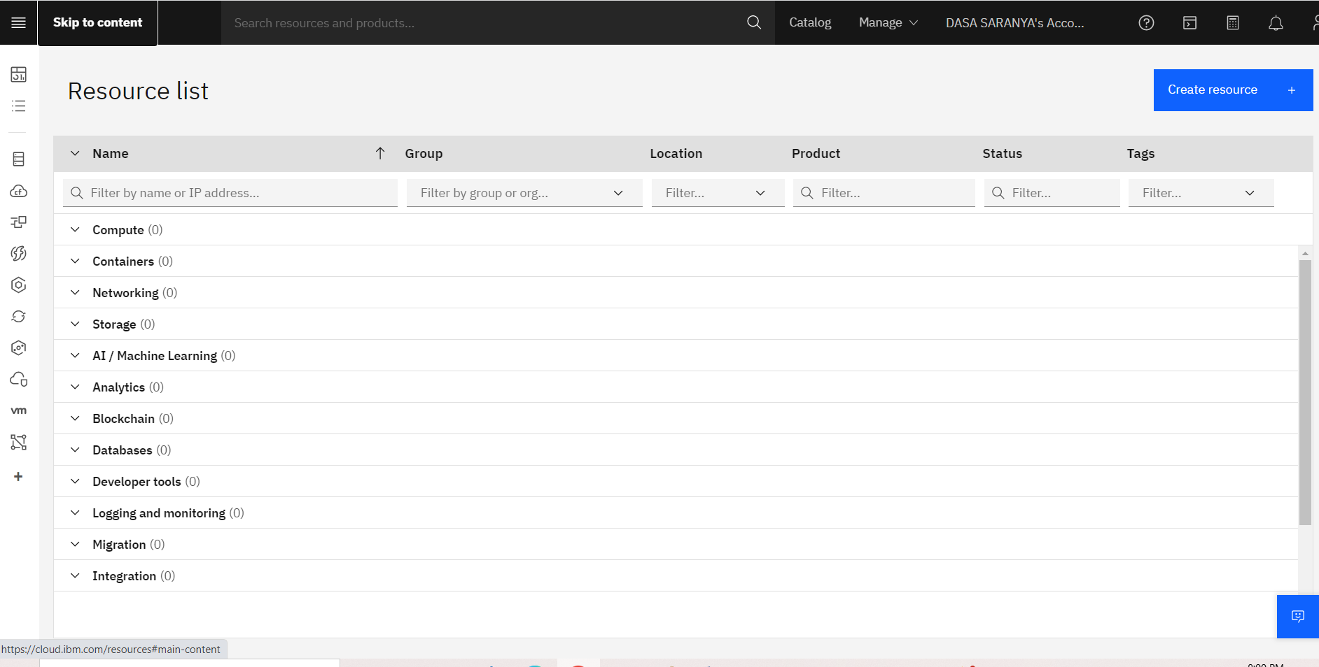

* IBM Watson IoT platform acts as the mediator to connect the web application to IoT devices, so create the IBM Watson IoT platform.

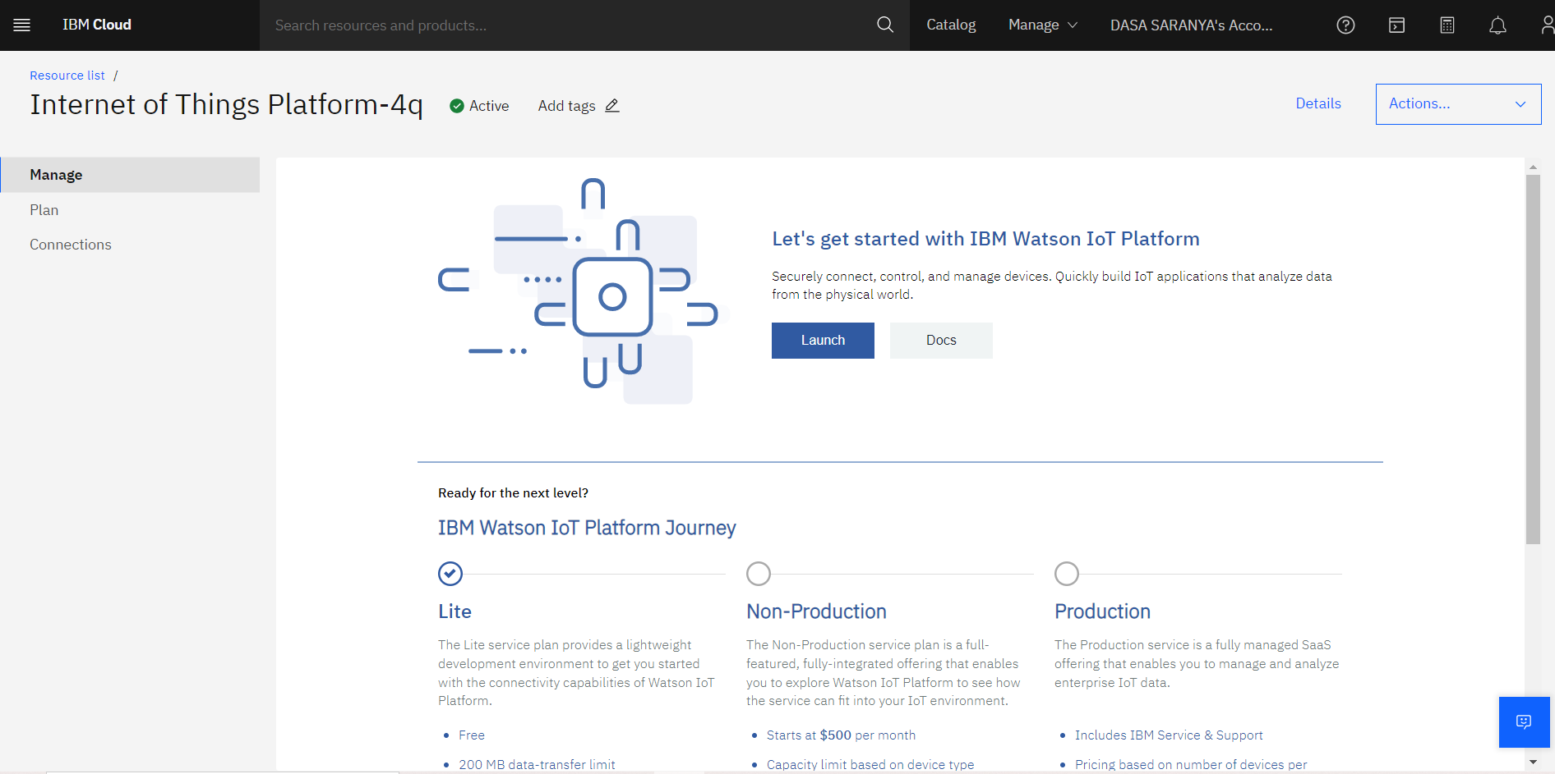

* In order to connect the IoT device to the IBM Cloud create a device in the IBM Watson IoT platform and get the device credentials.

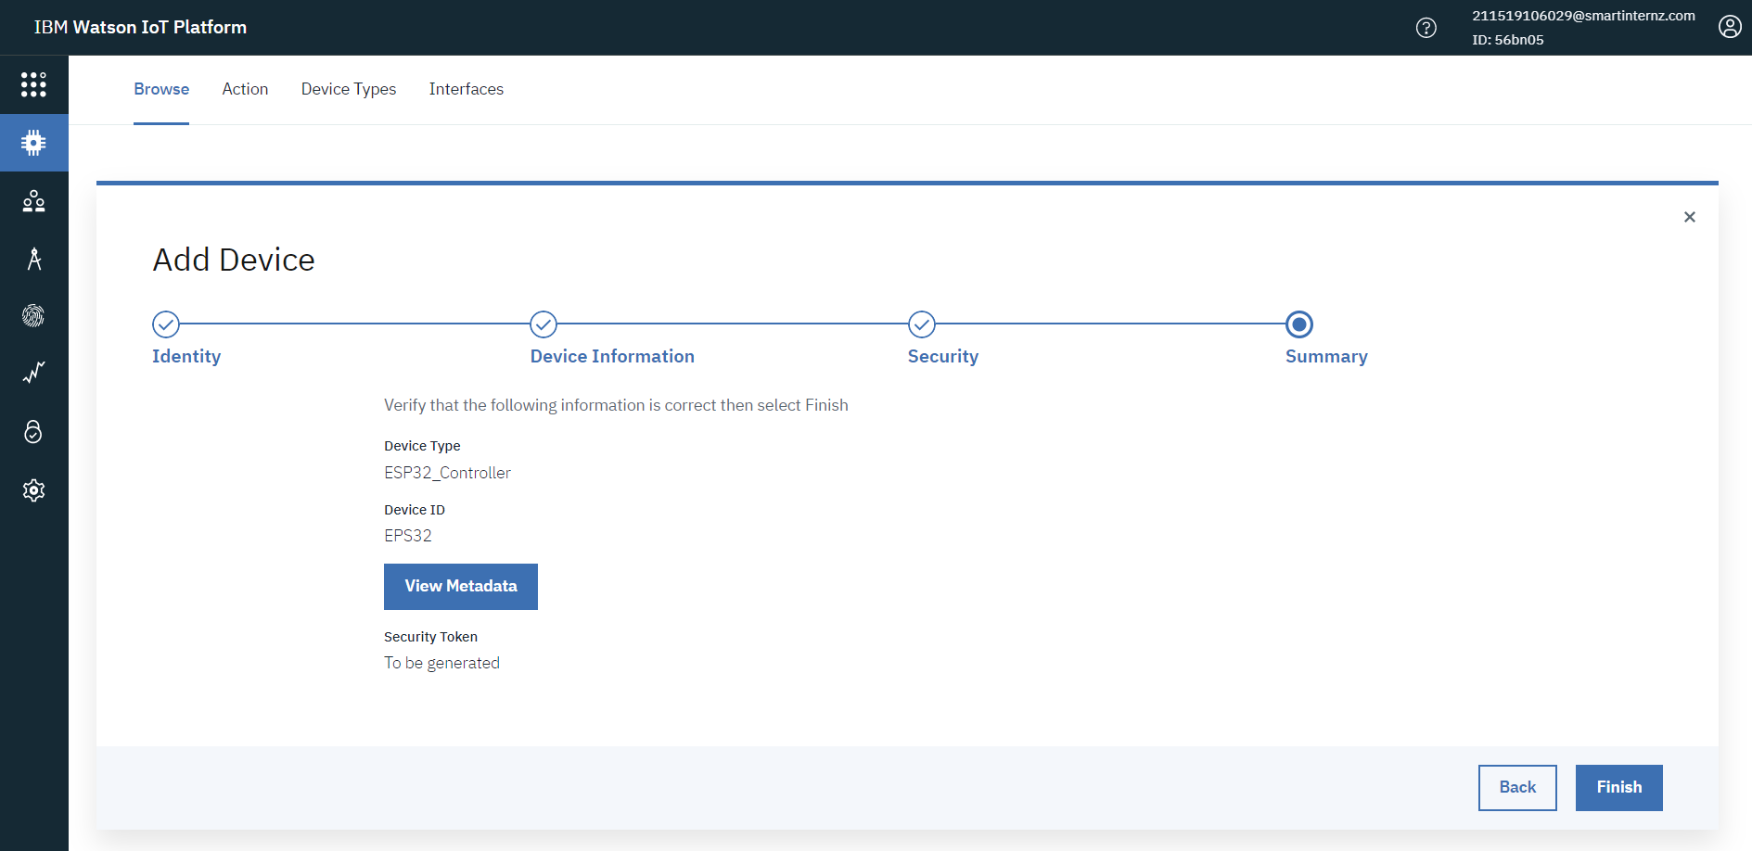

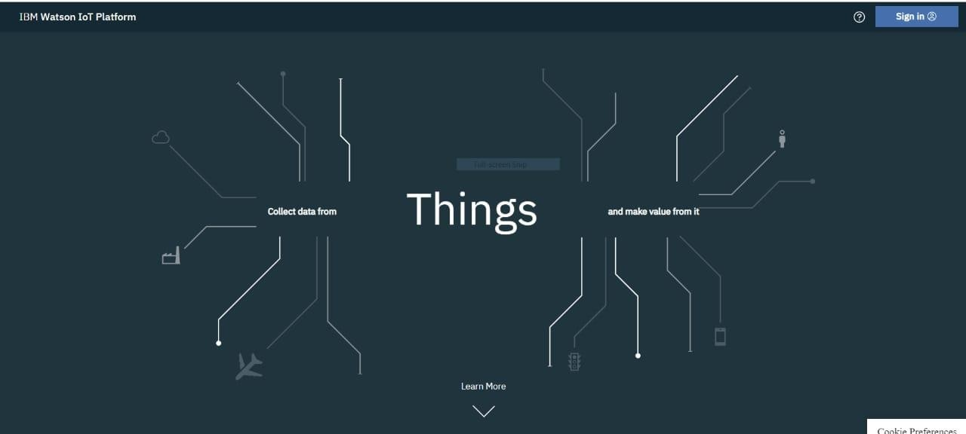

* Device Credentials Information:

